

JOMO KENYATTA UNIVERSITY OF AGRICULTURE & TECHNOLOGY

GYM SYSTEM MANAGEMENT
TECHNICAL REPORT STRUCTRED USING OOP PRINCIPLE & C++

PREPARED BY:
Name: GICHUHI KEVIN MUNYERE
Reg No: ENE211-0231/2025
Class: EEE 2.2 B1
^{4TH -May- 2026}

PRESENTED TO:
Department of Electrical Engineering
Miss Luciana

1. Introduction
The Gym Management System is a software solution designed to streamline the administrative operations of a modern fitness facility. The system provides a comprehensive set of tools for managing gym memberships, processing payments, and maintaining member records in an efficient and organized manner.
This report documents the technical architecture of the system, covering both the high-level system design and the functional block structure. It explains how each component interacts with others, how data flows through the system, and how the software is organized from a programming perspective.
The system was developed in C++ and leverages core OOP principles including inheritance, encapsulation, and polymorphism. Persistent data storage is achieved through file handling, and a stack-based undo mechanism provides operational safety for member deletions.

1.1 Objectives
- Provide a secure, admin-only login to protect member data.
- Allow registration of gym members with membership package and timing slot selection.
- Validate payments at the point of registration to ensure full fee collection.
- Enable searching, viewing, and deletion of member records.
- Support undo of accidental deletions using a stack data structure.
- Persist all member data to a text file for recovery between sessions.

1.2 Technology Stack
- Language: C++ (standard library, file I/O, STL)
- Data Structures: std::vector (member roster), std::stack (undo buffer)
- Storage: Plain-text flat file (gym_members.txt)
- Paradigm: Object-Oriented Programming with virtual functions and inheritance

2. System Architecture
- The system architecture describes the high-level organization of the Gym Management System how its major subsystems are structured, their responsibilities, and the relationships between them. The architecture follows a layered design pattern, separating concerns across the login layer, the controller layer, and the data layer.

2.1 Architecture Diagram
- Figure below illustrates the overall system architecture of the Gym Management System. The diagram shows the hierarchical flow from admin authentication at the top, through the central management controller, down to the three core functional modules, and finally to persistent data storage at the base.

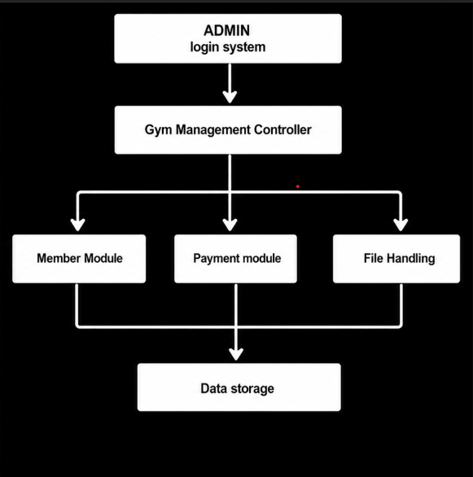

2.2 Architecture Layers Explained
The architecture is organized into four distinct tiers:

Layer 1: Admin Login System
This is the entry point of the entire application. The Admin class is instantiated in main() and its login() method is called before any gym operations are permitted. The user must supply a valid username and password combination. If authentication fails, the program terminates immediately, preventing any unauthorized access. This layer acts as a security gate for the entire system.

Layer 2: Gym Management Controller
The Gym Management System class serves as the central controller. It orchestrates all operations by calling methods on the underlying modules and maintaining the in-memory state of the application. It holds the member roster (vector<Member>) and the undo buffer (stack<Member>), and exposes a menu-driven interface through its menu() method. All user interactions are routed through this layer.

Layer 3: Functional Modules
Three modules are managed by the controller:
- Member Module: Encapsulates member data and input logic through the Member and Person classes. Handles collection of member ID, name, contact, membership type, and timing slot.
- Payment Module: The Payment class is composed within Member and handles fee validation, payment amount recording, and status tracking (PAID / NOT PAID).
- File Handling: The saveData() and loadData() methods in GymManagementSystem manage reading from and writing to gym_members.txt, providing persistence across sessions.

Layer 4: Data Storage
At the base of the architecture sits the persistent storage layer a plain-text file (gym_members.txt) written to disk. Each member's data is serialized line-by-line during save operations and deserialized on startup via loadData(). This ensures that all registered member records survive application restarts.

3. System Block Diagram
The system block diagram breaks down the Gym Management System into its operational functional blocks and shows the flow of control from the user through to data storage. Unlike the architecture diagram which shows structural layers, the block diagram focuses on the sequence of operations and the functional responsibilities of each module.

3.1 Block Diagram
Figure 2 below presents the functional block diagram of the system. Starting from the Admin/User at the top, it traces the control flow through login validation, the management controller, individual operation blocks (Add, Search, Delete, Undo), payment checking, file management, and finally data storage.

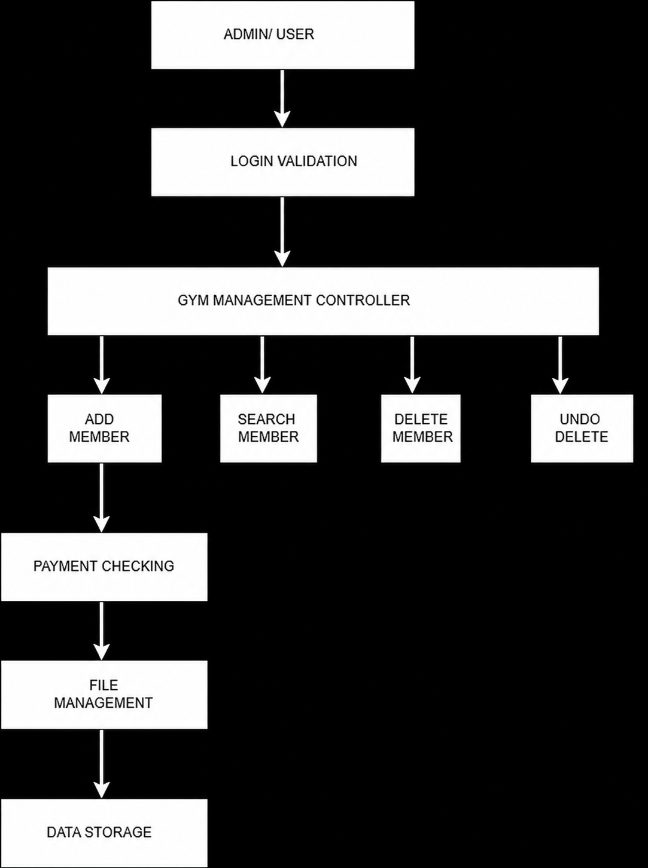

3.2 Explanation of Major Functional Blocks

Block 1: Admin / User
This is the actor who initiates the system. In the current implementation, there is a single administrator role no separate user tiers exist. The Admin interacts with the system exclusively through the console-based menu. All input is received via standard input (cin) and all output is presented on standard output (cout).

Block 2: Login Validation
Implemented within the Admin class, this block verifies the username and password entered at startup against hardcoded credentials (username: admin, password: gym123). If validation fails, the program returns exit code 0 and the Gym Management Controller is never instantiated. This block is a one-time gate once passed, the system proceeds to the main menu without re-authenticating.

Block 3: Gym Management Controller
This is the central processing block, implemented as the GymManagement class. It maintains the primary data containers (vector for active members, stack for deleted members) and exposes five operations through a numbered menu: Add Member, Display All Members, Search Member, Delete Member, and Undo Delete. It also triggers data persistence after any state-changing operation.

Block 4: Add Member
This block handles the full member registration workflow. It instantiates a Member object and calls its input() method, which collects: Member ID, Full Name, Contact Number, Membership Package (Gold at KES 2,500 or Silver at KES 2,000), Gym Timing Slot (6AM-7AM, 7AM-8AM, or 5PM-6PM), and Payment Amount. The block only adds the member to the roster if the payment validation in the next block succeeds.

Block 5: Search Member
This block accepts a Member ID from the administrator and performs a linear search through the vector<Member> roster. If a matching ID is found, the member's full profile is displayed using the display() method. If no match is found, a 'Member Not Found' message is shown. The search is read-only and does not modify any data.

Block 6: Delete Member
This block removes a member from the active roster. The administrator provides a Member ID; if found, the member object is pushed onto the deletedMembers stack before being erased from the members vector. This two-step process (push then erase) is what enables the undo functionality. After deletion, saveData() is called to sync the file.

Block 7: Undo Delete
This block reverses the most recent deletion using a LIFO (Last In, First Out) stack. The top element of the deletedMembers stack is popped and pushed back onto the members vector, effectively restoring the member. Only one undo per deletion cycle is supported at a time, but consecutive deletions can each be undone in reverse order. The data file is updated after each undo.

Block 8: Payment Checking
Implemented within the Payment class (composed inside Member), this block validates that the payment amount entered by the administrator is not less than the membership fee for the selected package. If the amount is below the required fee, registration is rejected and a failure message is displayed. If the amount meets or exceeds the fee, it is recorded and the payment status is set to PAID. The system does not support partial payments or installments.

Block 9: File Management
This block handles all read and write operations to the persistent storage file. saveData() serializes the members vector to gym_members.txt, writing each field on a new line. loadData() reads the file on startup and reconstructs Member objects into the vector. File I/O is managed using C++ fstream (ofstream for writing, ifstream for reading). If the file does not exist at startup, loadData() silently returns and the system starts empty.

Block 10: Data Storage
The gym_members.txt file is the sole persistence layer. It stores member records as plain text with one field per line. There is no database engine, no binary format, and no encryption. The file is overwritten in full on every save operation, meaning the entire member list is rewritten each time a change is made. This is appropriate for small datasets but would require optimization for larger-scale deployments.

4. Data
This section describes the data structures used within the system, the information fields stored per member, and the format in which data is persisted to disk. Understanding the data model is essential for evaluating the system's storage approach and identifying potential areas for future improvement

FIELD | DATA TYPE | DESCRIPTION
id | int | Unique numeric identifier for the member. Used for search and delete operations
name | string | Full name of the member, captured using getline() to support spaces.
contact | string | Member contact phone number. Stored as a large integer to accommodate 10-digit numbers.
membershipType | string | Membership tier: 'Gold' (KES 2,500) or 'Silver' (KES 2,000).
timing | string | Preferred gym session slot: 6AM-7AM, 7AM-8AM, or 5PM-6PM.
fee | float | The membership fee corresponding to the selected package.
Amount Paid | float | The actual amount paid by the member at registration. Must be >= fee
Payment status | bool | Boolean flag set to true when amountPaid exceeds KES 2,000

4.2 In-Memory Data Structures
Two primary data structures manage member data during program execution:

vector<Member> members
The main roster of all currently active gym members. The vector provides dynamic resizing, sequential access for display operations, and iterator-based deletion. It is loaded from disk on startup and persisted to disk after every state change.

stack<Member> deletedMembers
A LIFO stack that stores member objects that have been deleted during the current session. When a member is deleted, their full record is pushed onto this stack. The undoDelete() function pops the top entry and restores it to the active members vector. The stack is held in memory only and is not persisted to disk deleted members are lost if the program is closed before undoing the deletion.

4.3 File Storage Format
Member records are stored in gym_members.txt as plain text. Each member occupies 8 consecutive lines in the file, in the following order:

- Member ID (integer)Line 1:
- Full name (string)Line 2:
- Contact number (long long)Line 3:
- Membership type (string: Gold or Silver)Line 4:
- Timing slot (string)Line 5:
- Membership fee (float)Line 6:
- Amount paid (float)Line 7:
- Payment status (bool: 1 or 0)Line 8:

4.4 Data Validation Rules
The following validation rules are enforced at the point of data entry:

- Payment amount must be greater than or equal to the selected membership fee. Registration is aborted if this condition is not met.
- Member ID is entered as an integer; non-numeric input may cause undefined behavior due to reliance on cin >> without error handling.
- Timing and package selection defaults are applied if an out-of-range menu choice is entered (e.g., timing defaults to 'Not Selected' for invalid choices).
- Duplicate member IDs are not validated in the current implementation the system will register two members with the same ID if the same ID is entered twice.

4.5 Class Relationships & Inheritance
The system's OOP design uses the following class structure:

- Person (abstract base class): Declares virtual input() and display() methods, and holds common fields: id, name, contact.
- Member (extends Person): Implements input() and display(), and adds membershipType, timing, fee, and a composed Payment object.
- Payment (independent class, composed in Member): Manages amountPaid, paymentStatus, makePayment(), isPaid(), and paymentMessage().
- Admin (independent class): Handles login authentication with hardcoded credentials.
- GymManagement (controller class): Aggregates Member objects in a vector and stack, and drives all system operations.

5. Conclusion
The Gym Management System demonstrates a well-structured application of C++ OOP principles to solve a real-world administrative problem. The system successfully implements secure login, member registration with payment validation, record management (view, search, delete), undo functionality via a stack, and file-based persistence.

The layered architecture separates authentication, control logic, business logic, and storage making the codebase maintainable and extensible. With targeted enhancements to data validation, persistence of the undo stack, and migration to a structured storage format, the system could be scaled to support a production gym environment effectively.

